Chapter 7, Solution 85.

(a) The light is on from 75 volts until 30 volts. During that time we essentially have a 120-ohm resistor in parallel with a 6-µF capacitor.

v(0) = 75, v(∞) = 0, τ = 120x6x10⁻⁶ = 0.72 ms

v(t₁) = 75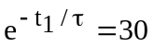 which leads to t₁ = –0.72ln(0.4) ms = 659.7 µs of lamp on time.

(b) 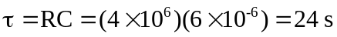

Since 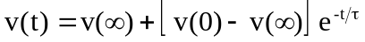
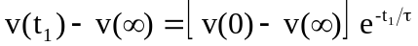 (1)
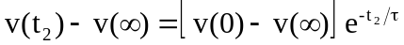 (2)

Dividing (1) by (2),
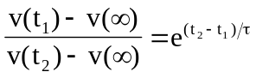
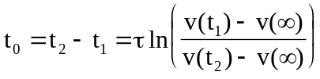
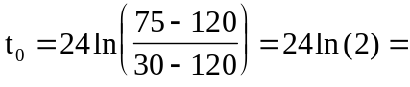16.636 s

